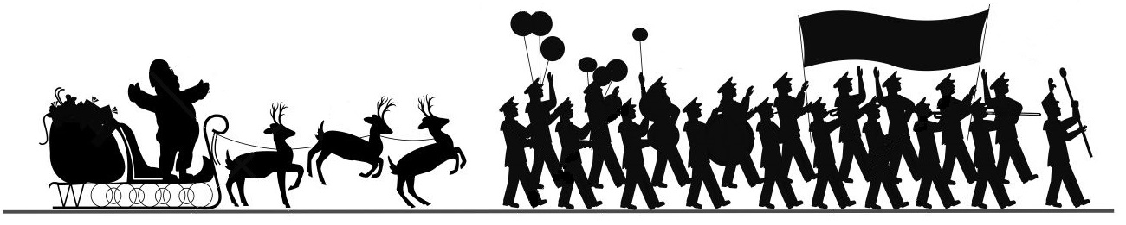

2024 City of Vincent Christmas Parade

Friday, December 6, 2024

6:00pm

I would like to participate in the 2024 City Of Vincent Christmas Parade.

I will be entering a:

o Decorated Float

o Decorated Car

o Other _______________________________________________________________

Business/Organization _________________________________________________

Contact Person ________________________________________________________

Phone Number ________________________________________________________

Email _________________________________________________________________

Parade line up will begin at 4pm at VMHS. Please be in line no later than 5:30pm.

Judging for the floats will begin at 5:30pm. Winners will be announced after the parade at the celebration ceremony.

Please call Vincent City Hall at 205-672-2261 for additional information.

Forms may be faxed to 205-672-7662

Or emailed to hthweatt@cityofvincental.com

Please have forms back by December 5, 2024 by 4pm

Please remember the **NO SANTAS** are permitted in the parade!

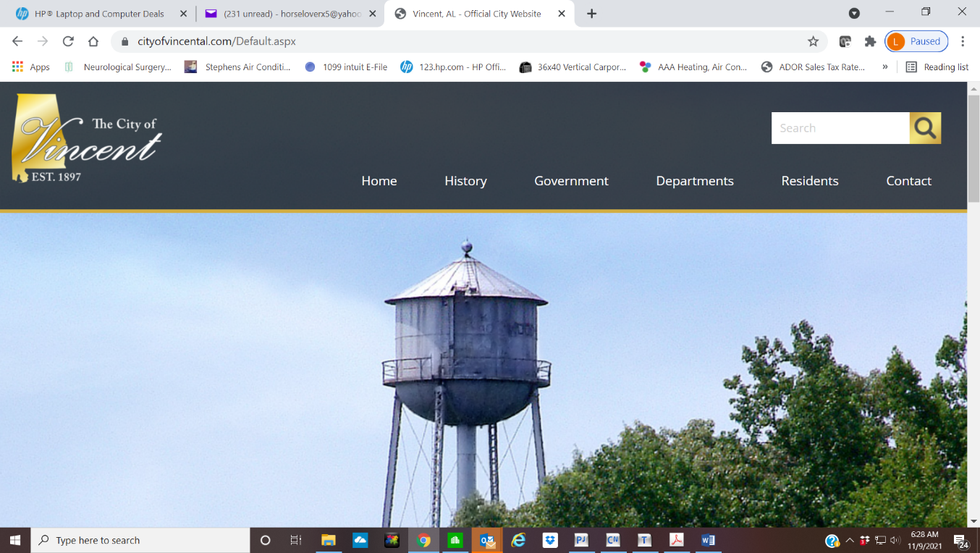 **Parade Liability Waiver Form**

Unconditional Waiver of Liability

I (print your name) representing

(print name of company/organization) recognize the efforts of the organizers, officers, directors, and staff of the City of Vincent, in organizing the annual City of Vincent Christmas Parade to be held on December 6, 2024. I also recognize that participation in said parade includes inherent risks of injury or damage to myself and to others. I further recognize and acknowledge the efforts of said organizers, officers, directors, and staff to obtain full coverage insurance for all riders and participants in said parade, and acknowledge their inability to obtain such blanket insurance coverage at reasonable and affordable prices. Therefore, in return for the privilege of participating in the City of Vincent Christmas Parade, I hereby give this, my unconditional waiver of liability and hold harmless agreement, to and in favor of the City of Vincent, together with all of its organizers, officers, directors, and staff.

By executing this waiver form, I do hereby state that I have the actual and legal authority to bind the organization on whose behalf I am executing same. Furthermore, I individually, and the organization upon whose behalf I am acting, agree to forever release and discharge the City of Vincent, together with all of their officers, directors, staff and employees, together with the organizers of the City of Vincent Christmas Parade from any and all liability for any injury or harm that I individually, or my organization may suffer as a result of participation in said parade or any activities that are preparatory or subsequent thereto.

This waiver and hold harmless agreement shall apply in favor of the City of Vincent, their officers, directors, employees and staff, together with the organizers of the Vincent Christmas Parade, regardless of whose act, fault or negligence shall have led to any such injury, harm or damage.

Signature of Participant Date